Degree Explorer

Austin Harvey

CST-451 Capstone Project Proposal

Grand Canyon University

Instructor: Professor Mark Reha

Revision: 1.0

Date: 11/1/2020

**ABSTRACT**

Tech Savvy is a simple and quick way to discover your future career in technology. When a user register, they are prompted to input a job title that will search for jobs in the field of technology. The application has a task of requesting and receiving data to display multiple jobs and their description on a table. The user has the option to view their history searches and save jobs to view in their profile. As an accomplishment, the application is made up of a .Net Core back-end and React front-end that continues to receive data using a REST API from the third-party GitHub Jobs API. Both project ends will transfer data between both ends to be displayed to the user. The secured application has a MYSQL database that hold registered users with security caches and is available on the Azure cloud.

|  |
| --- |
| History and Signoff Sheet |

**Change Record**

|  |  |  |
| --- | --- | --- |
| **Date** | **Author** | **Revision Notes** |
| 11/1/2020 | Austin Harvey | Initial draft for review/discussion |
|  |  |  |
|  |  |  |

|  |
| --- |
| **Overall Instructor Feedback/Comments** |

|  |
| --- |
| **Overall Instructor Feedback/Comments** |

**Integrated Instructor Feedback into Project Documentation**

Yes  No

**TABLE OF CONTENTS**

Functional Requirements 4

Non-Functional Requirements 5

Technical Requirements 6

Logical System Design 7

User Interface Design 8

Functional Requirements

**Use Cases**

Describe the sequence of functional actions a project performs with either textual Use Cases, UML Use Case diagrams, or if using Scrum, provide a link to the User Stories (see template included in course materials).

NOTE: Function requirements are listed in the Functional Requirements Back Log excel sheet.

Non-Functional Requirements

NOTE: Non-functional requirements are listed with the Functional Requirements Back Log excel sheet.

Technical Requirements

**Use Cases**

Describe the tools and technologies used in the project.

NOTE: Please see Technology Requirements excel sheet.

Logical System Design

Gather data from key

Third-Party API

Send data

Receive and request data from database

Cloud

Back-End

MYSQL Database

Project is accessible from the cloud

Request data

Receive data

Input key

Display API data

Front-End

User Interface Design

Provide a sitemap and user interface design diagram for each user interface screen in the application, if not applicable, define the components of the project as described in the handbook.

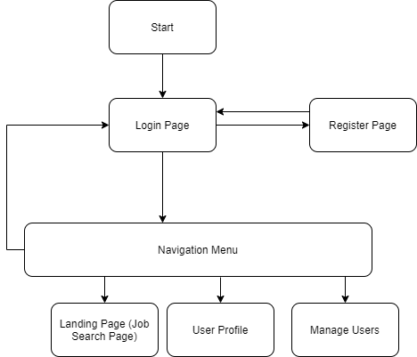

Web Application Sitemap

Web Application Wireframes

**Navigation Menu:**

**No User Session:**



**User in Session:**



**Login:**

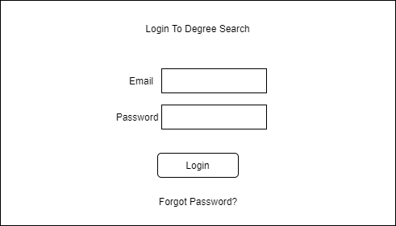

**Register:**

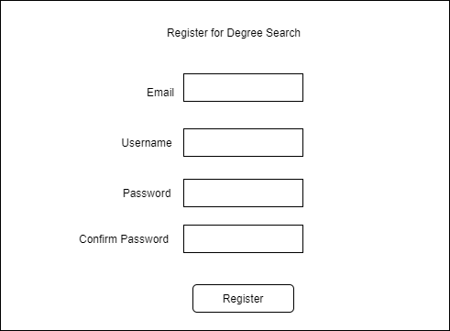

**Landing Page:**

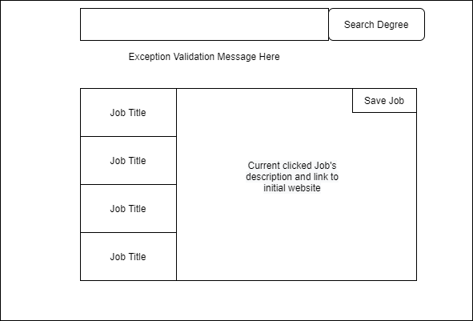

**User’s Profile:**

